**A**

**PROJECT REPORT**

***On***

**“Smart Vehicle Security and Maintenance System**

**using IoT”**

*Submitted in partial fulfillment of the requirements*

**For the degree of**

**BACHELOR OF ENGINEERING BY**

|  |  |
| --- | --- |
| **1. Mr. Gurvir Singh Bhogal** | (BE A - 122) |
| **2. Mr. Kishor Vavdra** | (BE A - 129) |
| **3. Mr. Mihir More** | (BE A - 134) |

Under the guidance of

**Prof. Sudhakar Jadhav**



**Lokmanya Tilak College Of Engineering**

Sector-4, Vikas Nagar, Koparkhairne, Navi Mumbai

**Department of Computer Engineering**

**(Year 2018-2019)**

**CERTIFICATE**

This is to certify that the project entitled **“Smart Vehicle Security And Maintenance**

**System Using IoT”** is a bonafide work of **Gurvir Singh Bhogal (BE-A 122) , Kishor Vavdra**

**(BE-A 129) ,** **Mihir More (BE-A 134)** submitted to the University Of Mumbai in partial

fulfillment of the requirement for the award of the degree of **Bachelor of Engineering** in

**Department of Computer Engineering.**

**-------------------------- --------------------------**

**(Name) Dr. Pravin Nikumbh**

**Project Guide Head**

**Department of Computer Engineering**

**PROJECT REPORT**

**“Smart Vehicle Security and Maintenance System**

**using IoT”**

|  |  |
| --- | --- |
| *Submitted* |  |
| *By* |  |
| **1. Mr. Gurvir Singh Bhogal** | (BE A - 122) |
| **2. Mr. Kishor Vavdra** | (BE A - 129) |
| **3. Mr. Mihir More** | (BE A - 134) |

**In partial fulfillment of the Degree of B.E. in computer Engineering is approved.**

**Guide:** **Examiner:**



**Prof. Sudhakar Jadhav** **(1) _____________________**

(Internal Guide) **(Signature)**

**(2) ______________________**

**(Signature)**

|  |  |  |
| --- | --- | --- |
|  | **__________________________** | |
| **Dr. Pravin Nikumbh** |  | **Dr. Vivek K. Sunnapawar** |
| **(Head of Department)** |  | **(Principal)** |

**Date of Submission :**

**(College Stamp)**

**TABLE OF CONTENTS**

Abstract………………………………………………………………………………...I

Acknowledgement……………………………………………………………………..II

List of Figures….………………………………………………………………………III

Table of Contents……………………………………………………………………….IV

**ABSTRACT**

This report presents the work done on the project Smart Vehicle Security and Maintenance System using IoT. Security of the vehicle in common parking places has been a matter of concern since ages, along with security the overall maintenance causes great inconvenience to the user. This project is an attempt to design and develop a smart system to prevent theft and to determine the exact location of the vehicle in addition with smart maintenance and monitoring. An efficient automotive security and maintenance system is implemented which involves IoT sensors transmitting real-time data from the vehicle to the user's mobile device. Maintenance such as Vehicle Servicing is calculated based on distance travelled and amount of fuel consumed. It also measures the vehicle performance on various factors, these factors are then processed through advanced algorithms providing improved safety and security of the vehicle. IoT technology transmits the on-board and off-board data from the vehicle which can be used to predict upcoming issues and suggest methods to repair them. A unique Radio-Frequency Identification (RFID) Card is designated to each individual vehicle providing access and improving the overall security. The owner can lock or unlock his or her vehicle using the RFID card. The Global Positioning System (GPS) is installed in the vehicle to track the online and offline location. Global System for Mobile communication (GSM) is used for transmitting vehicle parameters. This complete system is designed taking in consideration the low range vehicles to provide them extreme security and maintenance.

**I**

**ACKNOWLEDGEMENT**

We would like to express our sincere gratitude to several individuals and Lokmanya Tilak College of Engineering, Computer Department for supporting us throughout our study. First and foremost, we would like to express our sincere thanks to our Project Guide,

Prof. Sudhakar Jadhav, for his patience, enthusiasm, insightful comments, invaluable suggestions, helpful information, practical advice and unceasing ideas which have helped us tremendously at all times in development of this project. Our sincere thanks to Head of Department Dr. Pravin Nikumbh, for his continuous support and guidance in our project study. His immense knowledge, profound experience and professional expertise has guided us to reach the apex of our technical skills.

We also wish to express our sincere thanks to Lokmanya Tilak College of Engineering for supporting our project and providing us with the required infrastructure. We would also like to thank the entire Computer Department Staff for helping us and always providing necessary guidance with our project whenever we required assistance.

It is our privilege to express our gratitude to Principal of Lokmanya Tilak College of Engineering for providing us with an excellent environment to complete our work successfully.

Mr. Gurvir Singh Bhogal (BE A - 122)

Mr. Kishor Vavdra (BE A -129)

Mr. Mihir More (BE A - 134)

**II**

|  |  |  |
| --- | --- | --- |
|  | **LIST OF FIGURES** |  |
| **Fig No.** | **TITLE** | **Page No.** |
| Figure 1 | Gantt Chart Phase – I | 9 |
| Figure 2 | Gantt Chart Phase - II | 10 |
| Figure 3 | Web Application- Landing User Page Interface | 11 |
| Figure 4 | E-mail for Password Recovery | 12 |
| Figure 5 | Android Studio | 13 |
| Figure 6 | Android Application- Login Page User Interface | 14 |
| Figure 7 | Arduino Uno Board | 15 |
| Figure 8 | Fuel Level Sensor - SEN-2609 | 16 |
| Figure 9 | RFID Tool Kit | 16 |
| Figure 10 | GSM Module with antenna and 3G SIM slot | 18 |
| Figure 11 | Ublox neo 6m GPS module with Antenna | 18 |
| Figure 12 | ER Diagram | 19 |
| Figure 13 | Use Case Diagram | 19 |
| Figure 14 | Data Flow Diagram – Level 0, Level 1 | 20 |
| Figure 15 | Data Flow Diagram – Level 2 | 20 |

Figure 16 Activity Diagram 21

Figure !7 Sequence Diagram 21

Figure 18 Landing Page of kgmsecurity.tech 42

Figure 19 Login Page of Website Application 42

Figure 20 Sign up window for website 43

Figure 21 Location Tracking Page 43

Figure 22 Registration and Login of User in Android App 43

Figure 23 Dashboard Login of a User 44

Figure 24 Document Manager for User 45

Figure 25 Location and Alert Notification via Android App 45

**III**

|  |  |  |
| --- | --- | --- |
|  | **TABLE OF CONTENTS** |  |
| **SR NO.** | **TOPIC** | **PAGE NO.** |
| Chapter 1**. Introduction** | |  |
| 1.1 | Introduction | 1 |
| 1.2 | Motivation | 2 |
| 1.3 | Objectives and scope of work | 3 |
| 1.4 | Problem Statement | 5 |
| Chapter 2**.** | **Literature Survey** |  |
| 2.1 | Introduction | 6 |
| 2.2 | Review of Strengths and Weaknesses of Prior Studies | 7 |
| Chapter 3. **Requirement Specification** | |  |
| 3.1 | Existing System/Methodology/Technology | 8 |
| 3.2 | Proposed System/Methodology/Technology | 8 |
| 3.3 | Software Requirements | 9 |
| 3.4 | Hardware Requirements | 9 |
| 3.5 | Time Line Chart (Gantt Chart) | 10 |
|  |  |  |
| Chapter 4. | **System Analysis and Design** |  |
| 4.1 | Overview of the Modules and Subsystems | 11 |
| 4.2 | Diagrams/Tables/System Architecture | 19 |
| 4.3 | Algorithms Used | 22 |
|  |  |  |
| Chapter 5. | **Implementation** |  |
| 5.1 | Implementation Details of Algorithms / Pseudo-Code | 24 |
| 5.2 | Output / Screen Shots | 43 |
|  |  |  |
| Chapter 6. | **Conclusion** |  |
| 6.1 | Conclusion | 47 |
| 6.2 | Future Scope | 47 |
|  |  |  |
| Chapter 7. | **Reference** | 48 |
|  |  |  |
| **Annexure** | | 49 |
|  | |  |
|  |  |  |

**IV**

**Chapter 1. Introduction**

**1.1 Introduction**

Smart Vehicle Security and Maintenance System’s main aim is to provide additional security to the current vehicle interface along with providing various parameters that will serve as an input to the maintenance module, these parameters include Fuel Level indicator, Distance travelled, date of last vehicle servicing/repairing and Updating documentation. Additional parameters can also be added which can help improve the performance of the vehicle. Secondary aim of this project include keeping a track on the vehicle location and also keeping a track on the overall health, performance and documentations required for safe driving, all these parameters will help users improve their knowledge and have efficient, easily manageable dashboard provided as an Android Application.

Internet of Things and GPS technology helped create many wonders in the application of security of the vehicle. This hardware is fitted on to the vehicle in such a manner that it is not visible to anyone who is inside or outside of the vehicle. When the vehicle is moved without the owners permission the owner is alerted using the android application, the location data from tracking system can be used to find the current location and can be used by respected authorities for further action. This Vehicle tracking System can even detect unauthorized movements of the vehicle and then alert the owner. This gives an edge over other pieces of technology for the same purpose. When a request by user is sent to the number at the modem, the system automatically sends a return reply to that particular mobile indicating the position of the vehicle in terms of latitude and longitude. A Program has been developed which is used to locate the exact position of the vehicle and also to navigated track of the moving vehicle on Google Maps.

The Android Application is the major component of this project, the application will serve as a Dashboard for the user. The application includes various modules like location tracking, maintenance parameters tracking (such as fuel level, distance travelled), Document updation and vehicle access logs. The android application interacts with the GSM/GPS module for sending and receiving Input’s and Output’s for the IoT sensors. Whenever unauthorized access of the vehicle is detected the user will be receiving a notification through the android application. If fuel level is critically low or the date of servicing is due, a notification will be sent specifying the issue. RFID tags will be used before unlocking a vehicle to verify the authenticity of the user, if the RFID tag is invalid then an alert message is sent to the user.

Integration of IoT sensors to work in conjunction is critically essential for the system to provide efficient service to the end user. An easy to use consistent Android Application is developed which can function across a number of devices and can be used with ease. Protection of IoT devices from vehicle vibration and bad road conditions is also highly important, for this a protective case is being used along with high quality sensors and justified placement of sensors are chosen.

**1**

**1.2 Motivation**

Theft of vehicles have been a major topic of concern since the birth of automobile technology along with this the overall maintenance for good performance and long-life of the vehicles have been causing great inconvenience to the users. Integration of new technology to solve such problem became highly necessary. This project serves users with a dependable solution to the problem of theft and maintenance with the help of technologies such as Internet of Things and Android Development.

Considering the fact of growing demands of modern technology of Internet of Things and application development, has played a major role in providing motivation in undertaking this project. Being well-versed in such technologies can provide an edge in our technical skills and also help us gain experience in addition to our programming skills. As users of IoT devices and Android applications in everyday life we have been interested in this field since our interest in computing began. Our own experiences of using smartphones for course-work has led us to ponder many questions as to how Android Operating System and IoT devices in general work. This project has given us the opportunity to explore the world of Hardware to find out the answers to our questions.

Also considering the application of this project in various fields of Car navigation, Fleet management/tracking, Location Based Services enabled devices, Android Application based dashboard etc, the development of this project will help better understanding of all the applications and can be used to produce more and more productive results. The integration of computer devices with human life could be challenging and require extensive care to develop, the major role of this project is to help protect user vehicle from theft and also provide various parameters directly from the vehicle to the users android application. Considering all these points and the challenging aspects of this project majorly motivated us to develop this project.

**2**

**1.3 Objectives and scope of work**

The main objectives of this project includes the following points:

**1. To enhance the security of vehicles:**

Vehicle security such as locking and unlocking of the vehicle is improved Using Radio-Frequency Identification (RFID), a unique RFID tag will be provided to each user which can be used for locking and unlocking of the vehicle. If the RFID tag is scanned and verified correctly then authorization of the user is done and access of the vehicle is logged in the android application. If vehicle is unlocked without verifying the RFID tag then a notification will be sent to the user regarding unauthorized access of the vehicle and user can take necessary actions if required.

**2. Smart monitoring of vehicle through GPS tracker:**

The GPS tracker will provide additional security of the vehicle by keeping a track on the location of the vehicle with respect to parking, halt and navigation modes. If the user has set the mode to parking in the android application and if movement greater then an offset limit is reached then a alert message will be sent to the to inform about any malicious activities. The alert message could be in the form of text message or android notification. The GPS tracker can also locate the current position of the vehicle on Google maps. If any damage to the GPS tracker is found then last location of the vehicle could be accessed using the android application.

**3. Condition based maintenance:**

The IoT sensors are used for monitoring the vehicle parameters. The two parameters Critical Fuel level and Distance travelled will be available from the IoT devices. Other maintenance modules such as Documentation and the dates of last servicing/repairing(oil change, washing, etc) can be saved by the user itself. Dates exceeding a certain duration or fuel level lower than critical level or distance more than a particular offset will trigger the maintenance notification.

**4. Protection against theft of vehicles:**

The overall integration of IoT sensors along with the android application will provide the required security and protection of the vehicle from theft. The GPS tracker can locate the vehicles location if stolen, the RFID tag can determine if a legitimate user is accessing the vehicle or not, the android application can track the last location if sensors are damaged and can be helpful for the authorities to track down the vehicle. Hence the overall system will act as a secure way to keep a track and protect the vehicle from theft.

**3**

**5. Efficient use of Iot Components and proper integration:**

The Iot components will be mounted on the vehicle and efficient integration of components

ensure the power supply is steady at 5V which is the operating voltage which is fetched from the

vehicle. The Iot components co-ordinate to provide security for the vehicle under various

circumstances. The installation of the components is a one time process and maintenance of

components is affordable. The components will ensure that the warranty of vehicle would not be

void.

**The scope of work includes:**

Smart Vehicle Security and Maintenance System involves interconnection of various sensors with Arduino uno board, sensors such as GSM/GPS tracker, Fuel Level sensor, RFID scanner, Distance tracker. The integration of these modules with an Android application will provide us with security and maintenance of vehicle. Using the Android application we can monitor various parameters of the vehicle, using the GPS tracker will provide us with the current location, messages will be sent and received with the help of GSM module. Authentication will be provided with the help of RFID tags and scanner. The android application will help us to store various documents of the vehicle and user.

The deliverable for this project include an Android application which will be used as a dashboard for the end user and the IoT hardware components which will be installed on the end users vehicle to provide Security and maintenance. This project will provide the users with efficient, economical and advanced solution to recurring problems with vehicle security and maintenance. The application will provide the user to monitor their vehicle in real-time.

Arduino uno will serve as the main component and will act as a platform to connect and control Inputs and Outputs of various sensors. The various sensors which will be used in this project include RFID scanner which will be used for authentication of the user. GSM/GPS sensor will be used for tracking the location of the vehicle and provide services for communication between mobile application and the vehicle. Fuel level sensors will indicate the critical fuel level. The Android application will act as a Dashboard for the user to monitor and access various feature of the system.

The tentative deadline for this project is March 2019. The overall estimated cost of Arduino Uno, Sensor installation along with the development of Android Application will be approximately 2000 Rs – 2500 Rs.

**4**

**1.4 Problem Statement**

The Aim of Smart Vehicle Security and Maintenance System is to implement an Internet of Things and Android Application based technique to solve the real-time problem of vehicle security and protection from theft, which has been a major concern to address in the modern society. Along with Security and Protection the overall maintenance of the vehicle including servicing/repairing, updating documentation, checking the fuel level, amount of distance travelled causes great inconvenience to the user. This project highly focuses on developing a smart solution to such problems. Users currently have no contact with the vehicle whenever the vehicle is parked at a location, this problem is solved by using a GPS tracker and RFID tags to access the vehicle.

Authorities usually require some information about a stolen vehicle such as a Vehicle Identification Number (VIN) which is basically a serial number or the last seen location of the vehicle. This information can be provided readily from a centralized storage on a smartphone device. This system can not only provide the last seen location of the vehicle it can also provide the authorities with current position of the vehicle by using the GPS tracker. The GPS tracker is placed in such a position which is difficult to access and cannot be seen from outside that is the position of the GPS tracker is basically hidden which makes it difficult for intruders to cause harm to the sensor. This application can be used to solve the problem of vehicle theft and also help users be aware of what activities is happening in their vehicle.

A number of documents are required in order to drive a vehicle safely these documents are difficult to manage and can accidentally cause inconvenience to the user. These documents include Vehicle Registration, License, Valid Insurance certificate, Pollution Under Control (PUC) certificate etc. In order to manage these number of documents and also keeping in mind the dates of validity, the android application can prove to be an effective solution. The application can inform the user about expired documentation, the links to update the documents online.

Many a times users forget to check the fuel level before starting a trip which ends up in vehicle stopping at unusual places and will require towing services to transmit the vehicle to the nearest petrol station. This problem can be solved by indication the fuel level whenever it reaches a critical level. The delayed monthly servicing can also end it decreasing the overall performance of the vehicle which is also solved by notifying the user with the help of software programming.

**5**

**Chapter 2. Literature Survey**

**2.1 Introduction**

The literature survey is conducted by referring papers publish in the International Research Journal of Engineering and Technology (IRJET) and International Journal of Materials, Mechanics and Manufacturing. The papers which we have referred are “A Smart Anti-theft System for Vehicle Security” by the authors “Pritpal Singh, Tanjot Sethi, Bibhuti Bhusan Biswal, and Sujit Kumar Pattanayak” and a review paper titled “Smart Anti-theft System for the Security of Vehicles – A review” by the authors “Abhilash R. Lomate, Shilpa Mahore, Bhavesh S. Bhopale, Prof. Nilima R. Kharsan”.

A vehicle tracking system is an electronic device installed in a vehicle to enable the owner or a third party to track the vehicles location. The paper proposed to design a vehicle tracking system that works using GPS and GSM technology, which would be source of vehicle tracking and it would work as anti-theft system. It is an embedded system which is used for tracking and positioning of any vehicle by using Global Positioning System (GPS) and Global system for mobile communication (GSM). This design will continuously monitor a moving Vehicle and report the status of the Vehicle on demand. For doing this they have used a GSM and GPRS module. A GSM modem is used to send the position (Latitude and Longitude) of the vehicle from a remote place .The GPS modem will continuously give the data i.e. the latitude and longitude indicating the position of the vehicle. The same data is sent to the mobile at the other end from where the position of the vehicle is demanded. When the request by user is sent to the number at the GSM modem, the system automatically sends a return reply to that mobile indicating the position of the vehicle in terms of latitude and longitude in real time.

The system consists of GPS module, GSM modem , Infrared sensors, DTMF decoder IC MT8870DE, 8051 microcontroller, relay switch, vibration sensor, paint spray and high voltage mesh. In case of accident this system automatically sends the message for help to ones relatives. The preventive measures like engine ignition cutoff ,fuel supply cutoff, electric shock system (installed on steering wheel) and paint spray system are installed in the vehicle which is controlled using user or owner GSM mobile. The owner can lock or unlock his/her vehicle with the help of SMS.

This hardware is assembled on the vehicle in such a way that it is invisible to the person inside or outside of the vehicle. If any interrupt to the system then it sends location information to the monitoring unit. To find the location of vehicle, location information from tracking system is used in case if the vehicle is stolen and can be informed to police for taking actions. It also alerts the owner by detecting unauthorized movement of vehicle.

**6**

**2.2 Review of strengths and weaknesses of prior studies**

**Strengths**

* The Project uses GSM and GPS module which is the most cheapest way of providing security since in 21 th the use of mobile technology has increased rapidly.
* This hardware is assembled on the vehicle in such a way that it is invisible to the person inside or outside of the vehicle.
* The security provided is of maximum strength and cannot be surpassed easily moreover the processor used is hard-coded and gives precise outputs.
* The vehicle can be tracked with the help of GPS and GSM module online through application and also offline through the messaging application.

**Weakness**

* The system is not economical as the components used are outdated and need a lot of maintenance as compared to the Arduino uno since it has higher shelf life.
* The response time is slow because the processor becomes slow and laggy after some extensible use.
* The hardware used requires a lot of space and modifications needs to be done to the vehicular layout which may void the warranty.
* Tweaking with the voltage and fuel regulation may lead to problems if installation is not done properly.
* The user needs to use the mobile device everytime to authorize himself and it might lead to some issues if the device is not found or stolen hence the alternative use of RFID is suggested.

**7**

**Chapter 3. Requirement Specification**

**3.1 Existing System/Methodology/Technology**

The present system has GSM/GPS modem which is used to track the vehicle and send the longitude and latitude of the present location of the vehicle on the mobile phone app.This system does not alert the user if the vehicle has been started by any other person/unauthorized person. The current system provides location when user demands for it. A security alert is popped when the location of vehicle is moved from the original location.A major drawback of this project is that if the mobile phone is not accessible the user will fail to make use of the security provided by the project. The app does not provide the user any alternative to access its own account. User will not be able to track the current fuel level of the vehicle and the system will not provide user with any knowledge of the maintenance of the vehicle. These drawbacks will be overcome by our proposed system.

**3.2 Proposed System/Methodology/Technology**

A Smart Vehicle Security and Maintenance System is being developed with the help of Internet of Things and Android Development, along with various programming languages such as C/C++, Java, Php and hardware implementation of devices such as RFID scanner, Arduino uno which can be helpful in improving and providing Security to a Vehicle. Along with Security the use of IoT sensors such as GSM/GPS modem, Fuel Level Sensor, Distance tracker and Software implementation for storing Users Documents and Logs will provide a way to monitor the vehicle and maintain the performance and overall health of the vehicle.

This system can track the current location of the vehicle and check various parameters with the help of an Android Application. This Android application will serve as a Dashboard which would be used by the end user. Protection of the vehicle from theft will be provided with the help of a GSM/GPS tracker which can transmit real time data to the android application. Security will be provided by RFID scanner, anyone trying to access the vehicle without the correct RFID tag will not be authorized to access, and a alert message will be sent on the owners mobile device.

The Android Application serves as a primary user interface between to get input and send output to the hardware installed to a particular vehicle. The linking of the hardware device with the owners mobile device is done using GSM/GPS modem. This modem can send and received SMS/Voice/Data packets, which are used for transmission purposes. Documentation require as be the RTO laws can be efficiently scanned and saved at the mobile device itself. Access of the vehicle will be saved in a Log file which can be viewed on the mobile application.

Overall goal of this project is to create a network between the vehicle and the owners mobile device with the help of hardware and software implementation so that users can track their vehicle with ease and monitor various parameters of the vehicle with the convenience of being at any place the user wishes to be.

**8**

**3.3 Software requirements**

1. Operating System: Linux, Windows 10 / 8 / 7
2. Web Application Server: Apache
3. Front End: HTML, CSS, Bootstrap, JavaScript, XML
4. Back End: PHP, Java
5. Database: FireBase, SQLite

**3.4 Hardware requirements**

Minimum Requirements :-

1. Device: Android Version KitKat 4.4 – 4.4.4 and above
2. RAM: 1GB
3. Disk Space: 300MB
4. Mobile Service Provider (WSP): Any SIM provider with 3G connectivity

**3.5 Time Line Chart (Gantt Chart)**

The Timeline Chart is used to display the list of activities carried out by the project team over the course of time period. The timeline has been divided into 2 phases i.e. Phase 1 (Sem 7) is period of initial project development which shows the activities done in this period. Phase 2 (Sem 8) is the period when the implementation and prototype was build.

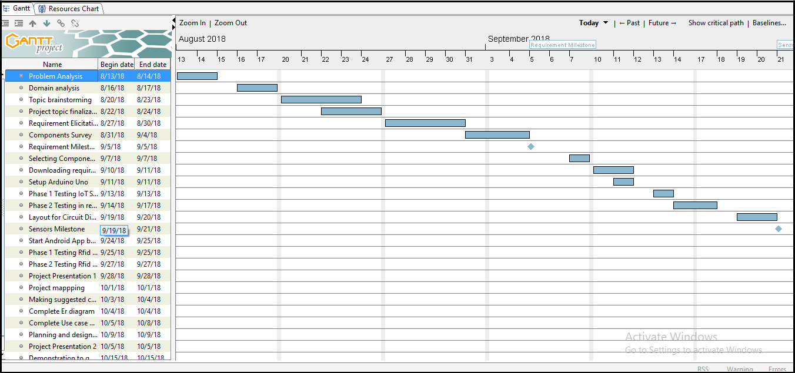

**9**

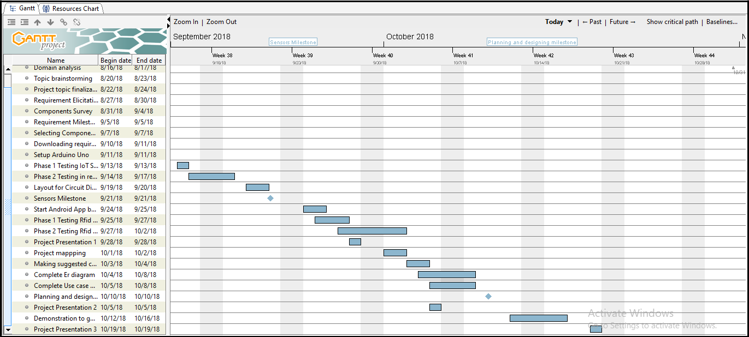

**Figure 1: Gantt Chart – Phase 1**

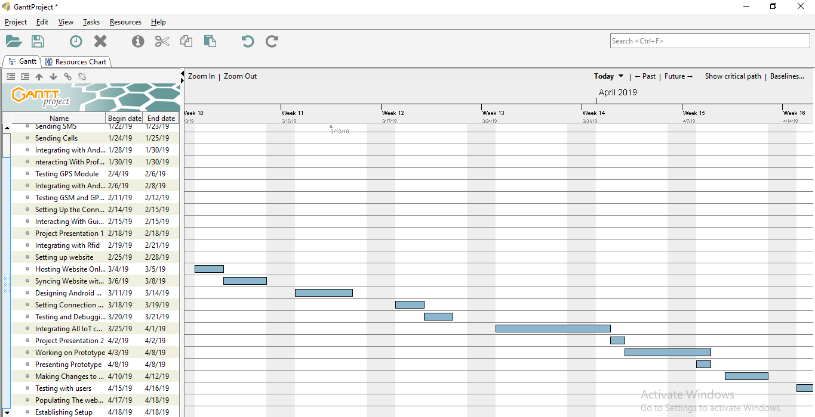

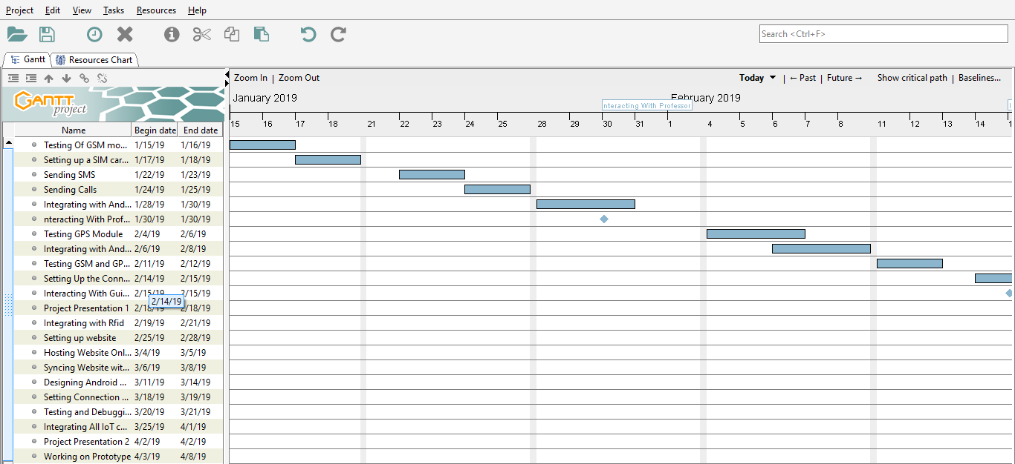

**Figure 2 : Gantt Chart –Phase 2**

**10**

**Chapter 4. System Analysis and Design**

**4.1 Overview of the modules and subsystems**

The implementation of this project is based on modular design, a module is a separate unit of software or hardware. Typical characteristics of modular components include portability, which allows them to be used in a variety of systems, and inter-operability, which allows them to function with the components of other systems.

The modules included in this project are as follows:

**1. Web Application:**

The Web Application will serve as an additional feature along with the android application. The web application will provide the user with information about the product, contact information, user login, log access, documentation manager and information validation.

The web application will be working on Apache server, the front end will be developed with HTML,CSS and JavaScript. The back end will be developed with PHP.

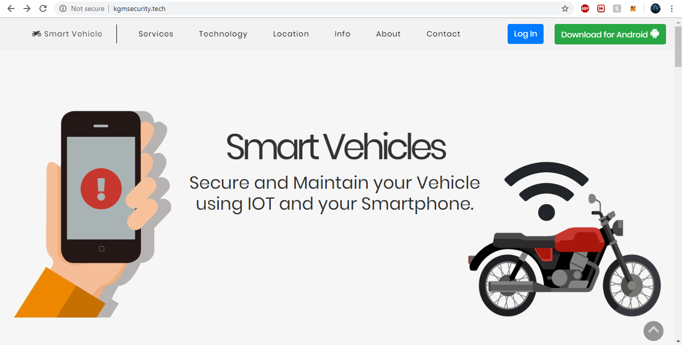

**Figure 3 : Web Application- Landing Page User Interface**

**11**

The Web Application also provides a functionality of retrieving a user’s account if the password is incorrect.This can be done by clicking on the forgot password button. A mail will be sent on the registered email-id containing the username and password of the user account.

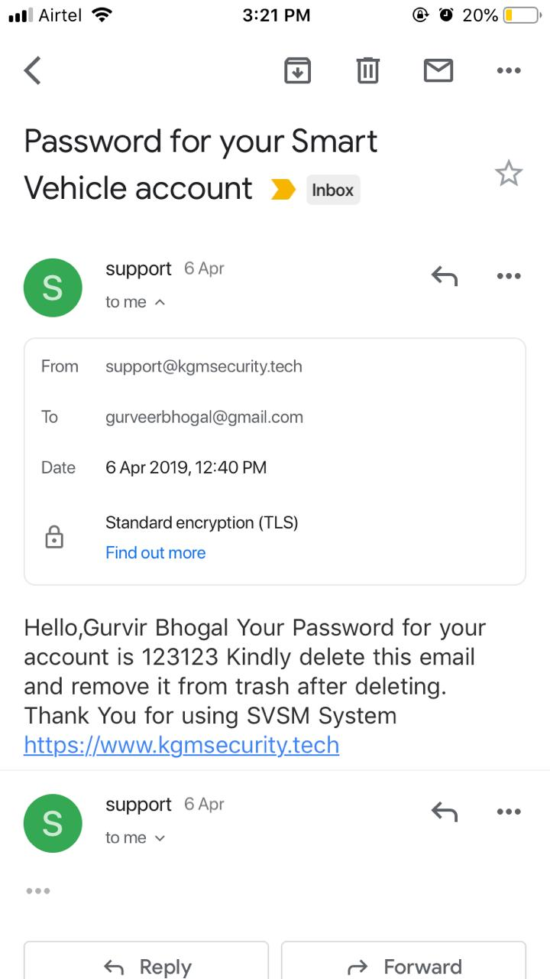

**Figure 4 : E-mail for password recovery**

**2. Android Application:**

Android is a mobile operating system developed by Google, based on a modified version of the Linux kernel and other open source software and designed primarily for touchscreen mobile devices such as smartphones and tablets.

Android is also associated with a suite of proprietary software developed by Google, called Google Mobile Services (GMS) that very frequently comes per-installed in devices, which usually includes the Google Chrome web browser and Google Search and always includes core apps for services such as Gmail, as well as the application store and digital distribution platform Google Play, and associated development platform. provided in the current stable version:

* Gradle-based build support
* Android-specific refactoring and quick fixes
* Lint tools to catch performance, usability, version compatibility and other problems
* Template-based wizards to create common Android designs and components
* A rich layout editor that allows users to drag-and-drop UI components, option to preview layouts on multiple screen configurations

**12**

* Support for building Android Wear apps
* Built-in support for Google Cloud Platform, enabling integration with Firebase Cloud Messaging (Earlier 'Google Cloud Messaging') and Google App Engine
  + Android Virtual Device (Emulator) to run and debug apps in the Android studio.
  + The Document Manager is used to manage and store documents in the android app. These documents can be viewed anytime from the app.
  + The Alert button has a log file of all the messages and alerts send by the vehicle to the user. The user can monitor the vehicle activity.
  + The maintenance button helps the user to remind about the distance travelled and when to service your vehicle according to the distance travelled and amount of fuel consumed.

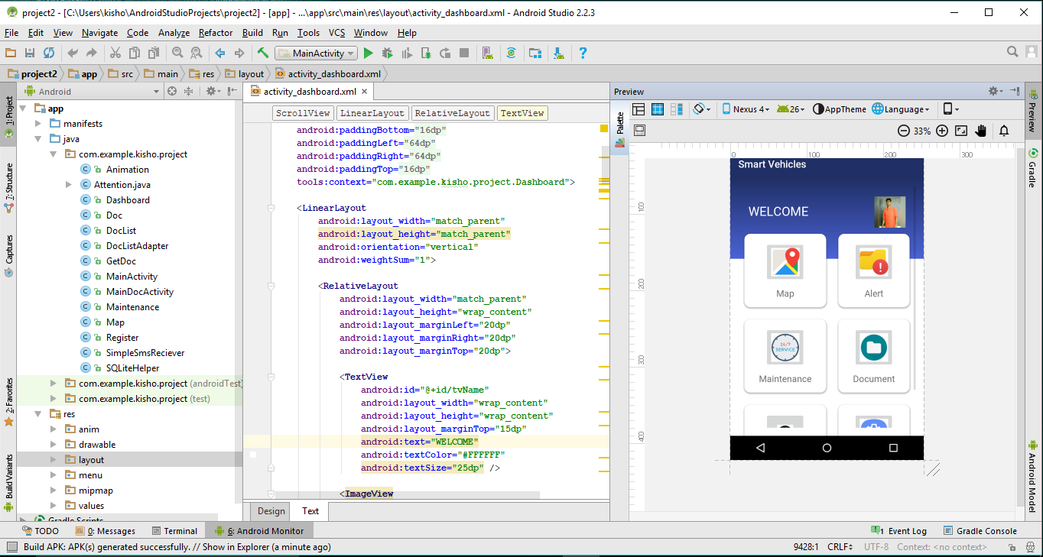

**Figure 5 : Android Studio**

The android app will consist of the following modules:

4.1 Login Page

4.2. Location tracking for Security

4.3. Fuel Level, Distance Tracking, Servicing

4.4. Documents and Details

**13**

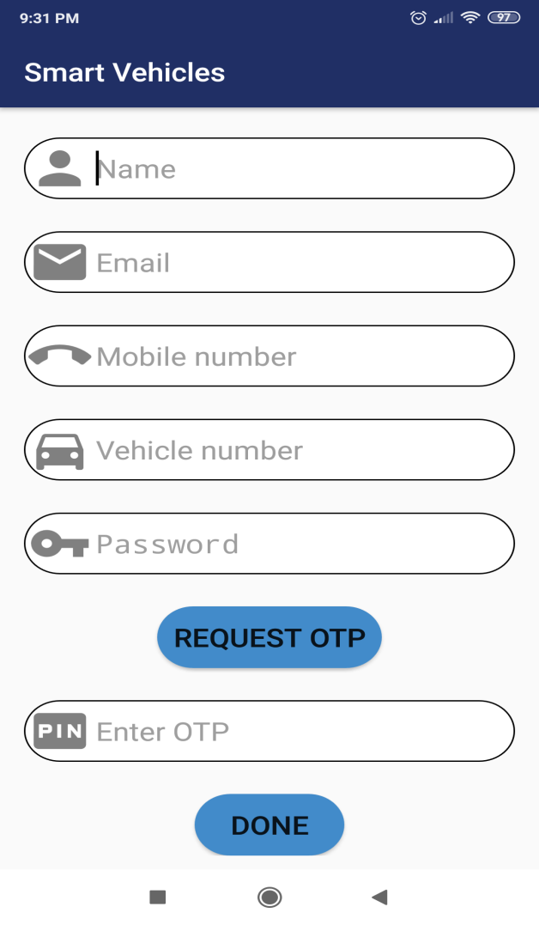

**Figure 6 : Android Application- Login User Interface**

1. **IoT sensors Installation:**

**5.1 Arduino Uno Board:**

The Arduino UNO is an open-source micro controller board based on the Microchip ATmega328P micro controller and developed by Arduino.cc. The board is equipped with sets of digital and analog input/output (I/O) pins that may be interfaced to various expansion boards (shields) and other circuits. The board has 14 Digital pins, 6 Analog pins, and programmable with the Arduino IDE (Integrated Development Environment) via a type B USB cable. It can be powered by a USB cable or by an external 9 volt battery, though it accepts voltages between 7 and 20 volts. It is also similar to the Arduino Nano and Leonardo.

The hardware reference design is distributed under a Creative Commons Attribution Share-Alike 2.5 license and is available on the Arduino website. Layout and production files for some versions of the hardware are also available. "Uno" means one in Italian and was chosen to mark the release of Arduino Software (IDE) 1.0. The Uno board and version 1.0 of Arduino Software (IDE) were the reference versions of Arduino, now evolved to newer releases.

**14**

The Uno board is the first in a series of USB Arduino boards, and the reference model for the Arduino platform.The ATmega328 on the Arduino Uno comes preprogrammed with a bootloader that allows uploading new code to it without the use of an external hardware programmer. It communicates using the original STK500 protocol. The Uno also differs from all preceding boards in that it does not use the FTDI USB-to-serial driver chip. Instead, it uses the Atmega16U2 (Atmega8U2 up to version R2) programmed as a USB-to-serial converter.

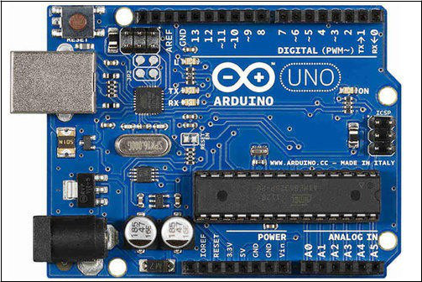

**Figure 7 : Arduino Uno Board**

**5.2. Fuel Level Sensor :**

Fuel Level Sensor detects the level of fuel in the fuel tank as fuels exhibit upper free surface. The level measurement can be either continuous or point values. Continuous level sensors measure level within a specified range and determine the exact amount of substance in a certain place, while point-level sensors only indicate whether the substance is above or below the sensing point. Generally the latter detect levels that are excessively high or low. The fuel sensor used in the project is a discrete sensor and determines whether the fuel level is above or below the specified limit (i.e reserve).

1. It will detect the fuel level
2. Notify user when the fuel level is critical

**15**

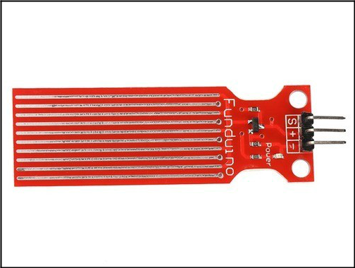

**Figure 8 : Fuel Level Sensor - SEN-2609**

**5.3. RFID Tag:**

The MFRC522 is a highly integrated reader/writer IC for contactless communication at 13.56 Mhz. RFID Tag of 13.56 Mhz for close range detection (&lt;10cm) is used.

2.5 V to 3.3 V power supply is required which can be provided by arduino uno board. It will provide authentication to the vehicle. Radio-frequency identification (RFID) uses electromagnetic fields to automatically identify and track tags attached to objects. The tags contain electronically-stored information. Passive tags collect energy from a nearby RFID reader's interrogating radio waves. Active tags have a local power source (such as a battery) and may operate hundreds of meters from the RFID reader. Unlike a barcode, the tag need not be within the line of sight of the reader, so it may be embedded in the tracked object. RFID is one method for Automatic Identification and Data Capture (AIDC).

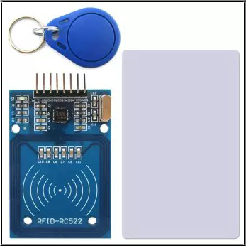

**Figure 9 : RFID Tool Kit**

**16**

**5.4. GPS and GSM Installation:**

The Global Positioning System (GPS) is the only fully functional Global Navigation System (GNSS). The features include:

1. Support voice calls and sms
2. Support mobile and Unicom 2G, as well as the global GSM network
3. GPRS data characteristics, the maximum data rate, download 85.6Kbps, upload 42.8Kbps;
4. Will provide current location of vehicle
5. Will sent sms to the user and recieve

GPS uses a constellation of between 24 and 32 Medium Earth Orbit satellites that transmit precise microwave signals that enable GPS receivers to determine their location, speed, direction, and time. A GPS receiver receives the signals from at least three satellites to calculate distance and uses a triangulation technique to compute its two dimension (latitude and longitude) position or at least four satellites to compute its three dimension (latitude , longitude and altitude) position. Therefore GPS is a key technology for giving device its position.

A GSM modem is a specialized type of modem which accepts a SIM card, and operates over a subscription to a mobile operator, just like a mobile phone.GSM (Global system for mobile) uses a process called circuit switching.

This method of communication allows a path to be established between two devices. Once the two devices are connected, a constant stream of digital data is relayed.GSM networks consist of thee major systems the Switching System (SS), The Base Station(BSS) and the Mobile station(MS).

GSM Modem parameter and specification:

|  |  |
| --- | --- |
| Frequency band | Quad band 850/900/1800/1900 |
|  |  |
| Transmission power | 2 W @850/ 900 MHz |
| 1 W @800/1900MHz |
|  |
|  |  |
| Power supply | 12V, 1A - |
|  |  |
| Operating temperature | 40 °C to 85 °C |
|  |  |

**17**

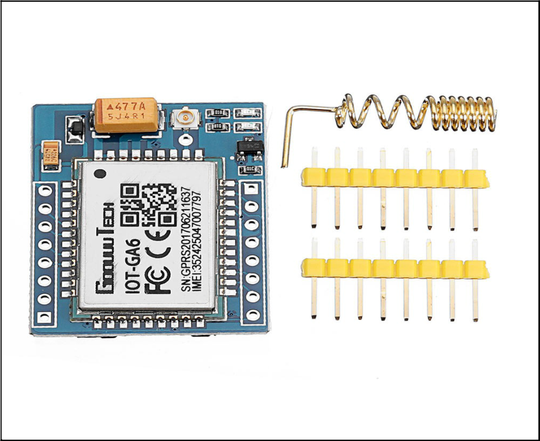

**Figure 10 : GSM Module with antenna and 3G SIM slot**

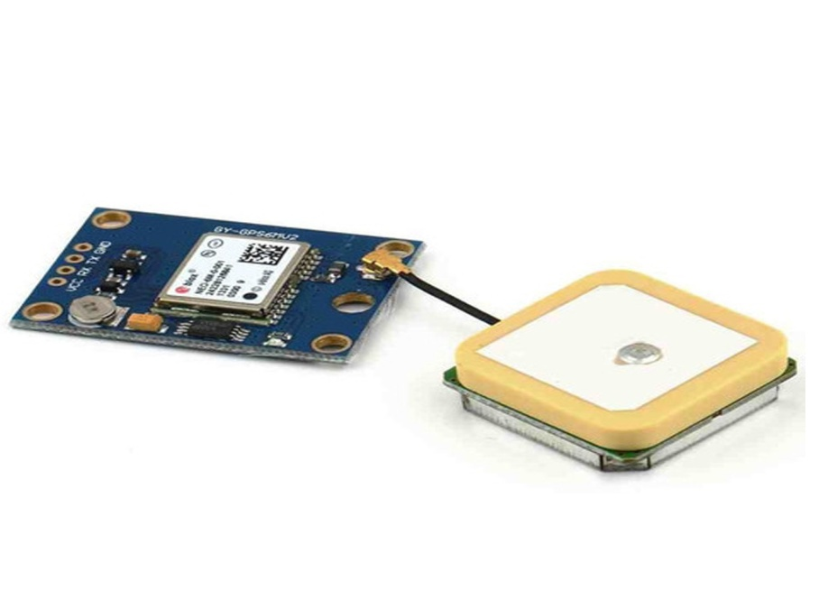

**Figure 11 : Ublox neo 6m GPS module with Antenna**

**18**

**4.2. Diagrams/Tables/System Architecture**

**ER Diagram**

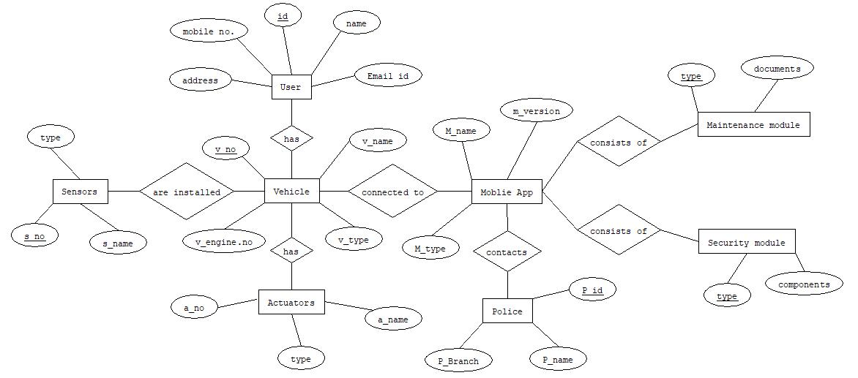

**Figure 12 : ER Diagram**

**Use Case Diagram**

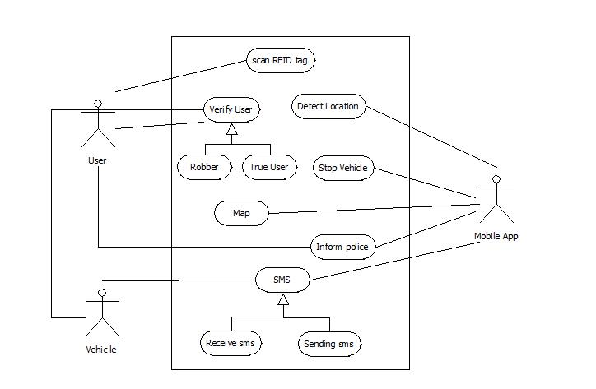

**Figure 13 : Use Case Diagram**

**19**

**Data Flow Diagrams**

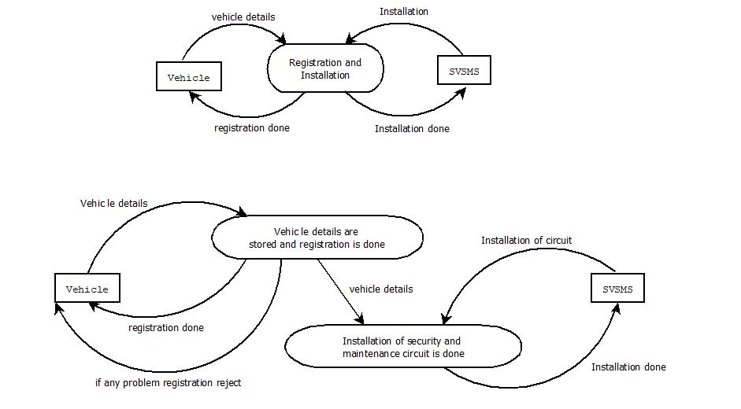

**Figure 14 : Data Flow Diagram – Level 0, Level 1**

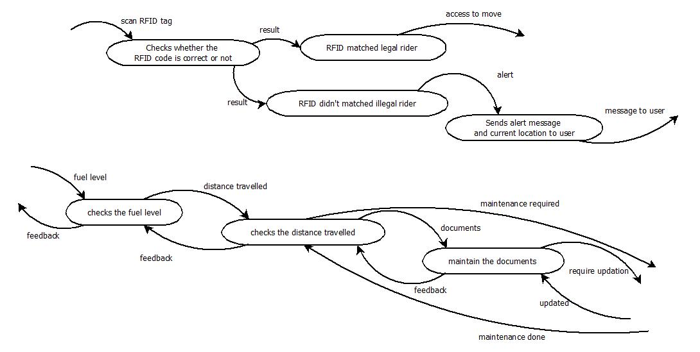

**Figure 15 : Data Flow Diagram – Level 2**

**20**

**Activity Diagram**

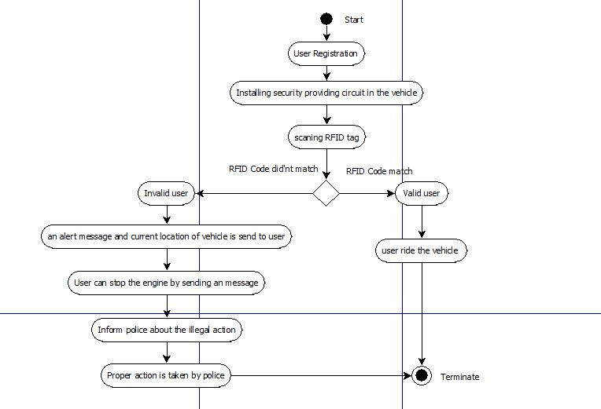

**Figure 16 : Activity Diagram**

**Sequence Diagram**

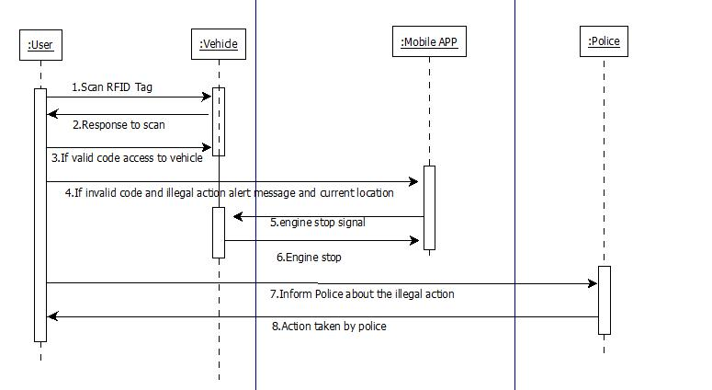

**Figure 17 : Sequence Diagram**

**21**

**4.3 Algorithms Used**

Various Algorithms for programming IoT sensors are used such as Analog Serial InOut Algorithm, GSM sms/call algorithms and GSM server and Web client algorithms.

**1. Analog Serial InOut Algorithm:**

// These constants won't change. They're used to give names to the pins used:

const int analogInPin = A0; // Analog input pin that the potentiometer is attached to const int analogOutPin = 9; // Analog output pin that the LED is attached to

int sensorValue = 0; // value read from the pot

int outputValue = 0; // value output to the PWM (analog out)

void setup() {

* initialize serial communications at 9600 bps: Serial.begin(9600);

}

void loop() {

// read the analog in value:

sensorValue = analogRead(analogInPin);

* map it to the range of the analog out: outputValue = map(sensorValue, 0, 1023, 0, 255);
* change the analog out value: analogWrite(analogOutPin, outputValue);
* print the results to the Serial Monitor: Serial.print("sensor = "); Serial.print(sensorValue); Serial.print("\t output = "); Serial.println(outputValue);
* wait 2 milliseconds before the next loop for the analog-to-digital
* converter to settle after the last reading:

delay(2);

}

1. **GSM Receive SMS Algorithm:** void setup() {
   * initialize serial communications and wait for port to open: Serial.begin(9600);

while (!Serial) {

* + - // wait for serial port to connect. Needed for native USB port only

}

**22**

Serial.println("SMS Messages Receiver");

* + connection state

boolean notConnected = true;

* Start GSM connection while (notConnected) {

if (gsmAccess.begin(PINNUMBER) == GSM_READY) {

tConnected = false;

} else {

Serial.println("Not connected");

delay(1000);

}

}

Serial.println("GSM initialized");

Serial.println("Waiting for messages");

}

void loop() {

char c;

* If there are any SMSs available() if (sms.available()) { Serial.println("Message received from:");
  + Get remote number sms.remoteNumber(senderNumber, 20); Serial.println(senderNumber);
  + An example of message disposal
  + Any messages starting with # should be discarded if (sms.peek() == '#') { Serial.println("Discarded SMS");

sms.flush();

}

* + Read message bytes and print them

while (c = sms.read()) {

Serial.print(c);

}

Serial.println("\nEND OF MESSAGE");

* Delete message from modem memory sms.flush(); Serial.println("MESSAGE DELETED");

}

delay(1000);

}

**23**

**Chapter 5. Implementation**

**5.1 Implementation details of Algorithm/Pseudo-Code**

**Website Source Code**

**Index.php**

<?php

session_start();

error_reporting(0);

require('textlocal.class.php');

if(isset($_POST['login']))

{

header("location:error.php?login=true");

if($_SERVER["REQUEST_METHOD"]=="POST"){

$conn = mysqli_connect('localhost','u966723543_root','testtest','u966723543_svsm');

$phone = $_POST["phone"];

$pass = $_POST["pswd"];

$sql = "SELECT `phone`,`name`,`pass`,`otp` from user where phone = $phone and pass = '$pass'";

$result = $conn->query($sql);

if($result->num_rows > 0){

while($row = $result->fetch_assoc()) {

$name = $row['name'];

$phone = $row['phone'];

$_SESSION['user'] = $name;

$_SESSION['phone'] = $phone;

if($row['otp']!= 0)

{

$_SESSION['phone'] = $phone;

header("location:otp_check.php");

}

else{

header("location:loggedin.php");

}

}

} else {

echo "Error Occured Check if you are registered!";

}

$conn->close();

}

}

if($_SERVER["REQUEST_METHOD"]=="POST"){

echo "Inside req method post";

define('host','localhost');

define('user','u966723543_root');

define('password','testtest');

define('db','u966723543_svsm');

**24**

$connect = mysqli_connect(host,user,password,db);

createUser();

}

function createUser(){

if(isset($_POST['submit1'])){

global $connect;

echo "Inside createUser() ";

$name = $_POST["name"];

$phone = $_POST["phone"];

$num = $_POST['num']."-".$_POST['num1']."-".$_POST['num2']."-".$_POST['num3'];

$pass = $_POST["pass"];

$email = $_POST['email'];

$conn = mysqli_connect('localhost','u966723543_root','testtest','u966723543_svsm');

$query = "SELECT phone from user where phone = '$phone'";

$result = $conn->query($query);

if($result->num_rows > 0){

while($row = $result->fetch_assoc()) {

header("location:error.php");

}

}

else{

echo "Inside else of createUser() ";

//Send OTP to user

$randno = rand(100000,999999);

$query = "Insert into user(name,email,phone,num,pass,otp) values ('$name','$email',$phone,'$num','$pass','$randno')";

if(mysqli_query($connect,$query)){

$_SESSION['phone'] = $phone;

$chk = 0;

$textlocal = new Textlocal(false, false, 'AoQAFQwOCNA-FzV1oSP7htsOiDo2pUyNawDP8HUSvr');

$numbers = array($phone);

$sender = 'TXTLCL';

$message = 'Hello, '.$name.'. Your OTP for SVSM is '.$randno.' https://www.kgmsecurity.tech';

try {

$result = $textlocal->sendSms($numbers, $message, $sender);

print_r($result);

} catch (Exception $e) {

die('Error: ' . $e->getMessage());

}

**25**

$chk++;

if($chk>0){

header('location:otp_check.php');

}

}

else{

header("location:error.php?login=true");

die (mysqli_error($connect));

mysqli_close($connect);

}

}

}

else{

echo "Inside createUser_mob else() ";

createUser_mob();

}

}

function createUser_mob(){

echo "Inside createUser_mob() ";

global $connect;

$name = $_POST["name"];

$phone = $_POST["phone"];

$num = $_POST['num']."-".$_POST['num1']."-".$_POST['num2']."-".$_POST['num3'];

$pass = $_POST["pass"];

$otp = $_POST["otp"];

$email = $_POST["email"];

$conn = mysqli_connect('localhost','u966723543_root','testtest','u966723543_svsm');

$query = "SELECT phone from user where phone = '$phone'";

$result = $conn->query($query);

if($result->num_rows > 0){

while($row = $result->fetch_assoc()) {

echo "You are already registered!";

}

}

else{

//echo "Inside createUser() else";

$query = "Insert into user(name,email,phone,num,pass,otp) values ('$name','$email',$phone,'$num','$pass',$otp)";

if(mysqli_query($connect,$query)){

$_SESSION['phone'] = $phone;

$chk = 0;

$textlocal = new Textlocal(false, false, 'AoQAFQwOCNA-FzV1oSP7htsOiDo2pUyNawDP8HUSvr');

$numbers = array($phone);

$sender = 'TXTLCL';

$message = 'Hello, '.$name.'. Your OTP for SVSM is '.$otp.' https://www.kgmsecurity.tech';

**26**

try {

$result = $textlocal->sendSms($numbers, $message, $sender);

print_r($result);

} catch (Exception $e) {

die('Error: ' . $e->getMessage());

}

$chk++;

if($chk>0){

header('location:otp_check.php');

}

}

else{

die (mysqli_error($connect));

mysqli_close($connect);

}

}}

?>

**Insert.php**

<!DOCTYPE html>

<html>

<head>

<meta charset="utf-8" />

<meta http-equiv="X-UA-Compatible" content="IE=edge">

<title>Smart Vehicle | Security and Maintenance</title>

<meta name="viewport" content="width=device-width, initial-scale=1">

<link rel="stylesheet" type="text/css" media="screen" href="main.css" />

<link rel="stylesheet" href="https://cdnjs.cloudflare.com/ajax/libs/animate.css/3.7.0/animate.min.css">

<!-- font awesome -->

<link rel="stylesheet" href="https://use.fontawesome.com/releases/v5.6.3/css/all.css" integrity="sha384-UHRtZLI+pbxtHCWp1t77Bi1L4ZtiqrqD80Kn4Z8NTSRyMA2Fd33n5dQ8lWUE00s/" crossorigin="anonymous">

<!-- Latest compiled and minified CSS -->

<link rel="stylesheet" href="https://maxcdn.bootstrapcdn.com/bootstrap/4.2.1/css/bootstrap.min.css">

<!-- jQuery library -->

<script src="https://ajax.googleapis.com/ajax/libs/jquery/3.3.1/jquery.min.js"></script>

<!-- Popper JS -->

<script src="https://cdnjs.cloudflare.com/ajax/libs/popper.js/1.14.6/umd/popper.min.js"></script>

<!-- Latest compiled JavaScript -->

<script src="https://maxcdn.bootstrapcdn.com/bootstrap/4.2.1/js/bootstrap.min.js"></script>

<!-- google font -->

<link href="https://fonts.googleapis.com/css?family=Poppins" rel="stylesheet">

<script src="main.js"></script>

<link rel="icon" href="/img/favicon.png" type="image">

</head>

<style>

body{

font-family:'Poppins', sans-serif;

}

#con_container{

**27**

height:670px;

width:100%;

background-color:#f6f6f6;

}

.slideInLeft{

animation-duration: 2s;

animation-delay: 1s;

}

.fadeIn{

animation-duration: 2s;

animation-delay: 3s;

}

.flash{

animation-duration: 1s;

animation-delay: 4s;

}

/* Style from index*/

.vl {

border-left: 1px solid #000000;

margin-left:20px;

}

#hover_nav{

color:#000000;

}

#hover_nav:hover{

color:#5e5e5e;

}

.nav-item{

margin-left:35px;

}

.jumbotron{

background-color:white;

}

@media screen and (min-width: 571px) and (max-width:1243px){

#hover_nav{

font-size:12px;

}

.nav-item{

margin-left:-5px;

}

.vl {

margin-left:2px;

}

#logo_disappear{

font-size:12px;

margin-top:3px;

}

}

**28**

@media screen and (min-width: 633px) and (max-width: 810px) {

#build_button{

width:50px;

}

.dl_txt{

display:none !important;

}

}

@media screen and (min-width: 571px) and (max-width: 633px) {

#build_button{

display:none !important;

}

.dl_txt{

display:none !important;

}

}

@media screen and (max-width: 573px) {

.logo1{

display: block !important;

}

#logo_disappear{

display:none !important;

}

.navbar-toggler{

z-index:100000;

margin-top:-50px;

}

}

#down_blink {

color:#333;

font-size:25px;

padding:20px;

border-radius:50%;

position:fixed;

bottom:0;

right:0;

margin-right:10px;

z-index:100000;

}

@keyframes blinker {

50% {

opacity: 0;

}

}

hr{

background-color:#ededed;

}

.logo1{

display:none;

position:relative;

**29**

z-index:10000;

font-size:20px;

text-align:center;

width:100%;

}

@media screen and (max-width: 517px) {

#login{

width:100px !important;

font-size:12px;

}

#signup{

width:100px !important;

font-size:12px;

}

#down_blink{}

}

@media screen and (max-width: 497px) {

#login{

width:100px !important;

font-size:12px;

}

#signup{

width:100px !important;

font-size:12px;

}

#account_lable{

margin-top:100px;

}

}

@media screen and (max-width: 449px) {

#login{

width:100px !important;

font-size:12px;

}

#signup{

width:100px !important;

font-size:12px;

}

#account_lable{

margin-top:150px;

}

}

@media screen and (max-width: 406px) {

#login{

**30**

width:100px !important;

font-size:12px;

}

#signup{

width:100px !important;

font-size:12px;

}

#account_lable{

margin-top:180px;

}

}

@media screen and (max-width: 414px) {

#login{

width:100px !important;

font-size:12px;

}

#signup{

width:100px !important;

font-size:12px;

}

#account_lable{

margin-top:180px;

}

}

@media screen and (min-width: 571px) and (max-width: 762px) {

#login{

width:100px !important;

font-size:12px;

}

#signup{

width:100px !important;

font-size:12px;

}

#account_lable{

margin-top:50px;

}

}

.bg-4 {

background-color: #cecece;

color:#333;

padding-top: 70px;

padding-bottom: 70px;

}

input[type=text], select, textarea {

width: 100%;

**31**

padding: 12px;

border: 1px solid #ccc;

border-radius: 4px;

box-sizing: border-box;

margin-top: 6px;

margin-bottom: 16px;

resize: vertical;

}

input[type=submit] {

background-color: #4CAF50;

color: white;

padding: 12px 20px;

border: none;

border-radius: 4px;

cursor: pointer;

}

input[type=submit]:hover {

background-color: #45a049;

}

/* End of Index Style */

.fadeInUp{

animation-duration: 3s;

}

@media screen and (max-width: 1336px){

#img-vec{

display:none;

}

#div1{

margin:0 auto !important;

position:relative !important;

background-color:#fff !important;

}

#div2{

background-color:#fff !important;

display:block !important;

}

#con_container{

display:none !important;

}

}

</style>

<body>

<nav class="navbar navbar-expand-sm navbar-light fixed-top" style="background-color:#f2f2f2;font-size:15px;letter-spacing:1px;">

<div class="logo1"><a class="nav-link" style="color:#333;" href="index.php"><i class="fas fa-motorcycle"></i></i> Smart Vehicle</a></div>

<button class="navbar-toggler" type="button" data-toggle="collapse" data-target="#collapsibleNavbar">

<span class="navbar-toggler-icon"></span>

**32**

</button>

<!-- add div and collapsable -->

<div class="collapse navbar-collapse" id="collapsibleNavbar">

<ul class="navbar-nav mr-auto" style="padding:5px;">

<li class="nav-item">

<a class="animated fadeInLeft nav-link" id="logo_disappear" style="color:#333;" href="index.php"><i class="fas fa-motorcycle"></i></i> Smart Vehicle</a>

</li>

<div class="vl"></div>

<li class="nav-item" >

<a class="animated fadeInLeft nav-link" href="#services"><span id="hover_nav"> Services</u></span></a>

</li>

<li class="nav-item" >

<a class="animated fadeInLeft nav-link" href="#tech"><span id="hover_nav"> Technology</span></a>

</li>

<li class="nav-item" >

<a class="animated fadeInLeft nav-link" href="#emergency"><span id="hover_nav"> Location</span></a>

</li>

<li class="nav-item" >

<a class="animated fadeInLeft nav-link" href="#shop"><span id="hover_nav"> Info</span></a>

</li>

<li class="nav-item" >

<a class="animated fadeInLeft nav-link" href="#about"><span id="hover_nav"> About</span></a>

</li>

<li class="nav-item" >

<a class="animated fadeInLeft nav-link" href="#contact"><span id="hover_nav"> Contact</span></a>

</li>

</ul>

<ul class="navbar-nav ml-auto">

<li class="nav-item">

<a href="app.apk" download><button class="animated fadeInLeft btn btn-bg btn-success" id="build_button"><span class="dl_txt">Download for Android</span> <i class="fab fa-android" style="font-size:22px;"></i></button></a>

</li>

</ul>

</div>

<div class="animated fadeInLeft" style="//background-color:yellow;width:500px;position:absolute;z-index:1000;margin-left:1000px;width:180px;//margin-top:600px;">

<a href="#login"><button class="btn btn-bg btn-primary" style="height:40px;" id="img-vec"><span class="dl_txt1">Log In</span></button></a>

</div>

</nav>

<script>

$('.navbar-nav>li>a').on('click', function(){

$('.navbar-collapse').collapse('hide');

});

**33**

</script>

<script>

if ($(window).width() > 1330){

$(document).ready(function () {

// Hide the div

$("#div1").hide();

// Show the div after 5s

$("#div1").delay(4000).fadeIn(100);

});

}

**Android Source Code**

**Attention.java :**

**package** com.example.kisho.project;

**import** android.content.ContentValues;

**import** android.content.Context;

**import** android.database.Cursor;

**import** android.database.sqlite.SQLiteDatabase;

**import** android.database.sqlite.SQLiteOpenHelper;

**import** android.support.v7.app.AppCompatActivity;

**import** android.os.Bundle;

**import** android.view.View;

**import** android.widget.Button;

**import** android.widget.TextView;

**import** android.widget.Toast;

**import** com.android.volley.AuthFailureError;

**import** com.android.volley.Request;

**import** com.android.volley.RequestQueue;

**import** com.android.volley.Response;

**import** com.android.volley.VolleyError;

**import** com.android.volley.toolbox.StringRequest;

**import** java.util.*;

**public class** Attention **extends** AppCompatActivity {

Button **btnSave**;

DbHandler **db**;

String **tp**;

TextView **tvData**, **tvmessage**;

RequestQueue **requestQueue**;

String **insertUrl** = **"https://www.kgmsecurity.tech/insert.php"**;

@Override

**protected void** onCreate(Bundle savedInstanceState) {

**super**.onCreate(savedInstanceState);

setContentView(R.layout.***activity_attention***);

**db** = **new** DbHandler(**this**);

**btnSave** = (Button) findViewById(R.id.***btnSave***);

**tvData** = (TextView) findViewById(R.id.***tvData***);

**tvmessage** = (TextView) findViewById(R.id.***tvmessage***);

Bundle extras = getIntent().getExtras();

**if** (extras != **null**) {

String address = extras.getString(**"MessageNumber"**);

String message = extras.getString(**"Message"**);

**34**

**if** (address.equals(**"+919867209272"**)) {

**tvmessage**.setText(message);

**tp** = message;

}

}

**final** StringBuffer sb = **new** StringBuffer();

ArrayList<Alert> st = **db**.viewResult();

**if** (st.size() == 0) {

**tvData**.setText(**"no records to show"**);

} **else** {

**for** (Alert m : st) {

sb.append(m.getDate() + **"\n"** + m.getMessage() + **"\n\n"**);

**tvData**.setText(sb.toString());

}

}

**btnSave**.setOnClickListener(**new** View.OnClickListener() {

@Override

**public void** onClick(View view) {

**final** String mes = **tp**;

**if** (mes != **null**) {

Date date = **new** Date();

String d = String.*valueOf*(date);

Alert s = **new** Alert(d, mes);

**db**.save(s);

StringRequest request = **new** StringRequest(Request.Method.***POST***, **insertUrl**, **new** Response.Listener<String>() {

@Override

**public void** onResponse(String response) { }

}, **new** Response.ErrorListener() {

@Override

**public void** onErrorResponse(VolleyError error) { }

}) {

@Override

**protected** java.util.Map<String, String> getParams() **throws** AuthFailureError {

java.util.Map<String, String> parameters = **new** HashMap<String, String>();

parameters.put(**"log"**, mes);

**return** parameters;

} };

**requestQueue**.add(request);}

}}); }

}

**class** DbHandler **extends** SQLiteOpenHelper {

SQLiteDatabase **db**;

Context **context**;

**public** DbHandler(Context context) {

**super**(context, **"alertdb"**, **null**, 1);

**this**.**context** = context;

**db** = **this**.getWritableDatabase();

}

@Override

**public void** onCreate(SQLiteDatabase db) {

db.execSQL(**"create table record(date text ,message varchar(50))"**);

}

@Override

**public void** onUpgrade(SQLiteDatabase db, **int** i, **int** i1) {

}

**35**

**public void** save(Alert s) {

Toast.*makeText*(**context**,s.getDate()+**""**+s.getMessage(), Toast.***LENGTH_SHORT***).show();

ContentValues c = **new** ContentValues();

c.put(**"date"**,s.getDate());

c.put(**"message"**,s.getMessage());

**long** rid = **db**.insert(**"record"**,**null**,c);

**if**( rid < 0 ) {

Toast.*makeText*(**context**, **" Issue in Saving "**, Toast.***LENGTH_SHORT***).show();

}

**else** {

Toast.*makeText*(**context**, **" Record Saved "**, Toast.***LENGTH_SHORT***).show();

}

}

**public** ArrayList<Alert> viewResult() {

Cursor c = **db**.query(**"record"**,**null**,**null**,**null**,**null**,**null**,**null**);

c.moveToFirst();

ArrayList<Alert> emp = **new** ArrayList<>();

**if**(c.getCount() > 0) {

**do** {

String date = c.getString(0);

String message = c.getString(1);

Alert s = **new** Alert(date,message);

emp.add(s);

}**while** (c.moveToNext());

}

**return** emp;

}}

**class** Alert {

**private** String **date**;

**private** String **message**;

**public** String getDate() {

**return date**;

}

**public** String getMessage() { **return message**; };

**public** Alert( String date,String message) {

**this**.**date** = date;

**this**.**message** = message;

}}

**Dashboard.java :**

**package** com.example.kisho.project;

**import** android.content.DialogInterface;

**import** android.content.Intent;

**import** android.content.SharedPreferences;

**import** android.content.pm.ActivityInfo;

**import** android.net.Uri;

**import** android.os.AsyncTask;

**import** android.support.v7.app.AlertDialog;

**import** android.support.v7.app.AppCompatActivity;

**import** android.os.Bundle;

**import** android.view.Menu;

**import** android.view.MenuInflater;

**import** android.view.MenuItem;

**import** android.view.View;

**import** android.widget.ImageButton;

**import** android.widget.ImageView;

**import** android.widget.TextView;

**36**

**import** android.widget.Toast;

**import** java.io.BufferedReader;

**import** java.io.IOException;

**import** java.io.InputStream;

**import** java.io.InputStreamReader;

**import** java.net.HttpURLConnection;

**import** java.net.MalformedURLException;

**import** java.net.URL;

**public class** Dashboard **extends** AppCompatActivity {

**private static final int *IMAGE_PICKER*** = 00;

TextView **tvName**;

SharedPreferences **sp1**;

ImageButton **ivSetting**,**ivDocumnet**,**ivMap**,**ivAlert**,**ivAbout**,**ivMaintenance**;

ImageView **ivPerson**;

@Override

**protected void** onCreate(Bundle savedInstanceState) {

**super**.onCreate(savedInstanceState);

setContentView(R.layout.***activity_dashboard***);

**int** o = ActivityInfo.***SCREEN_ORIENTATION_PORTRAIT***;

setRequestedOrientation(o);

**tvName** = (TextView)findViewById(R.id.***tvName***);

**sp1** = getSharedPreferences(**"Myp1"**,***MODE_PRIVATE***);

**ivSetting** = (ImageButton)findViewById(R.id.***ivSetting***);

**ivDocumnet** = (ImageButton)findViewById(R.id.***ivDocument***);

**ivMap** = (ImageButton)findViewById(R.id.***ivMap***);

**ivPerson** = (ImageView) findViewById(R.id.***ivPerson***);

**ivAlert** = (ImageButton)findViewById(R.id.***ivAlert***);

**ivAbout** = (ImageButton)findViewById(R.id.***ivAbout***);

**ivMaintenance** = (ImageButton)findViewById(R.id.***ivMaintenance***);

String name = **sp1**.getString(**"name"**,**""**);

**tvName**.setText(**"Welcome "**+name);

**ivPerson**.setOnClickListener(**new** View.OnClickListener() {

@Override

**public void** onClick(View view) {

OpenGallery();

}

});

**ivSetting**.setOnClickListener(**new** View.OnClickListener() {

@Override

**public void** onClick(View view) {

}

});

**ivDocumnet**.setOnClickListener(**new** View.OnClickListener() {

@Override

**public void** onClick(View view) {

Intent intent = **new** Intent(Dashboard.**this**,GetDoc.**class**);

startActivity(intent);

}

});

**ivMap**.setOnClickListener(**new** View.OnClickListener() {

@Override

**public void** onClick(View view) {

Intent i = **new** Intent(Intent.***ACTION_VIEW***);

i.setData(Uri.*parse*(**"geo:0,0?q="**+**"19.1058,73.0073"**));

startActivity(i);

}

});

**37**

**ivAlert**.setOnClickListener(**new** View.OnClickListener() {

@Override

**public void** onClick(View view) {

Intent intent = **new** Intent(Dashboard.**this**,Attention.**class**);

startActivity(intent);

}

});

**ivAbout**.setOnClickListener(**new** View.OnClickListener() {

@Override

**public void** onClick(View view) {

Intent i = **new** Intent(Intent.***ACTION_VIEW***);

i.setData(Uri.*parse*(**"http://"**+**"www.kgmsecurity.tech"**));

startActivity(i);

}

});

**ivMaintenance**.setOnClickListener(**new** View.OnClickListener() {

@Override

**public void** onClick(View view) {

Intent intent = **new** Intent(Dashboard.**this**,DocList.**class**);

startActivity(intent);

}

});

}

**private void** OpenGallery(){

Intent getImageIntent = **new** Intent(Intent.***ACTION_GET_CONTENT***);

getImageIntent .setType(**"image/*"**);

startActivityForResult(getImageIntent , ***IMAGE_PICKER*** );

}

@Override

**public void** onActivityResult(**int** requestCode, **int** resultCode, Intent data) {

**if** (requestCode== ***IMAGE_PICKER*** && resultCode == ***RESULT_OK***) {

Uri fullPhotoUri = data.getData();

**ivPerson**.setImageURI(fullPhotoUri);

}

}

@Override

**public boolean** onCreateOptionsMenu(Menu menu) {

MenuInflater me = getMenuInflater();

me.inflate(R.menu.***m1***,menu);

**return true**;

}

@Override

**public boolean** onOptionsItemSelected(MenuItem item) {

**if**(item.getItemId() == R.id.***logout***)

{

**sp1**.edit().remove(**"name"**).commit();

Intent i = **new** Intent(getApplicationContext(),MainActivity.**class**);

startActivity(i);

finish();

}

**return super**.onOptionsItemSelected(item);

}

**public void** onBackPressed() {

AlertDialog.Builder builder = **new** AlertDialog.Builder(**this**);

builder.setMessage(**"Do you want to EXIT ?"**);

builder.setCancelable(**false**);

builder.setPositiveButton(**"Yes"**, **new** DialogInterface.OnClickListener() {

@Override

**public void** onClick(DialogInterface dialogInterface, **int** i) {

finish();

**38**

}

});

builder.setNegativeButton(**"No"**, **new** DialogInterface.OnClickListener() {

@Override

**public void** onClick(DialogInterface dialogInterface, **int** i) {

dialogInterface.cancel();

}

});

builder.setNeutralButton(**"Cancel"**, **new** DialogInterface.OnClickListener() {

@Override

**public void** onClick(DialogInterface dialogInterface, **int** i) {

dialogInterface.cancel();

}

});

AlertDialog alert = builder.create();

alert.setTitle(**"EXIT"**);

alert.show();

}

**SimpleSmsReceiver.java :**

package com.example.kisho.project;

import android.content.BroadcastReceiver;

import android.content.Context;

import android.content.Intent;

import android.content.SharedPreferences;

import android.net.Uri;

import android.os.Bundle;

import android.telephony.SmsMessage;

import android.widget.Toast;

public class SimpleSmsReciever extends BroadcastReceiver {

private static final String TAG = "Message recieved";

@Override

public void onReceive(Context context, Intent intent) {

Bundle pudsBundle = intent.getExtras();

Object[] pdus = (Object[]) pudsBundle.get("pdus");

SmsMessage messages = SmsMessage.createFromPdu((byte[]) pdus[0]);

if(messages.getOriginatingAddress().equals("+919867209272")) {

if (messages.getMessageBody().contains("\n")) {

String message = messages.getMessageBody();

String[] split = message.split("\r\n");

Intent i = new Intent(Intent.ACTION_VIEW);

i.setData(Uri.parse("geo:0,0?q="+split[0]+","+split[1]));

context.startActivity(i);

} else {

Intent smsIntent = new Intent(context, Attention.class);

smsIntent.setFlags(Intent.FLAG_ACTIVITY_NEW_TASK);

smsIntent.putExtra("MessageNumber", messages.getOriginatingAddress());

smsIntent.putExtra("Message", messages.getMessageBody());

context.startActivity(smsIntent);

}

} }

}

**39**

**SQLiteHelper :**

**package** com.example.kisho.project;

**import** android.content.Context;

**import** android.database.Cursor;

**import** android.database.sqlite.SQLiteDatabase;

**import** android.database.sqlite.SQLiteOpenHelper;

**import** android.database.sqlite.SQLiteStatement;

**public class** SQLiteHelper **extends** SQLiteOpenHelper {

**private final** Context **context**;

SQLiteDatabase **db**;

**public** SQLiteHelper(Context context) {

**super**(context, **"Docdb.sqlite"**, **null**, 1);

**this**.**context** = context;

**db** = **this**.getWritableDatabase();

}

@Override

**public void** onCreate(SQLiteDatabase db) {

db.execSQL(**"CREATE TABLE IF NOT EXISTS DOC(ID INTEGER PRIMARY KEY AUTOINCREMENT, doc VARCHAR, val VARCHAR, image BLOG )"**);

}

@Override

**public void** onUpgrade(SQLiteDatabase sqLiteDatabase, **int** i, **int** i1) {}

**public void** queryData(String sql){

SQLiteDatabase database = getWritableDatabase();

database.execSQL(sql);

}

**public void** insertData(String doc, String val, **byte**[] image){

SQLiteDatabase database = getWritableDatabase();

String sql = **"INSERT INTO DOC VALUES (NULL, ?, ?, ?)"**;

SQLiteStatement statement = database.compileStatement(sql);

statement.clearBindings();

statement.bindString(1, doc);

statement.bindString(2, val);

statement.bindBlob(3,image);

statement.executeInsert();

}

**public void** updateData(**int** id, String doc, String val , **byte**[] image) {

SQLiteDatabase database = getWritableDatabase();

String sql = **"UPDATE DOC SET doc = ?, val = ?, image = ? WHERE id = ?"**;

SQLiteStatement statement = database.compileStatement(sql);

statement.bindString(1, doc);

statement.bindString(2,val);

statement.bindBlob(3, image);

statement.bindDouble(4, (**double**)id);

statement.execute();

database.close();

}

**public void** deleteData(**int** id) {

SQLiteDatabase database = getWritableDatabase();

String sql = **"DELETE FROM DOC WHERE id = ?"**;

SQLiteStatement statement = database.compileStatement(sql);

statement.clearBindings();

statement.bindDouble(1, (**double**)id);

statement.execute();

database.close();

}

**40**

**public** Cursor getData(String sql){

SQLiteDatabase database = getWritableDatabase();

**return** database.rawQuery(sql, **null**);

}

}

**Map.java:**

import android.content.Intent;

import android.content.SharedPreferences;

import android.net.Uri;

import android.os.AsyncTask;

import android.support.v7.app.AppCompatActivity;

import android.os.Bundle;

import android.view.View;

import android.widget.Button;

import android.widget.EditText;

import android.widget.Toast;

import com.android.volley.AuthFailureError;

import com.android.volley.Request;

import com.android.volley.Response;

import com.android.volley.VolleyError;

import com.android.volley.toolbox.StringRequest;

import com.android.volley.toolbox.Volley;

import java.io.BufferedReader;

import java.io.IOException;

import java.io.InputStream;

import java.io.InputStreamReader;

import java.net.HttpURLConnection;

import java.net.MalformedURLException;

import java.net.URL;

import java.nio.Buffer;

import java.util.HashMap;

public class Map extends AppCompatActivity {

SharedPreferences sp;

@Override

protected void onCreate(Bundle savedInstanceState) {

super.onCreate(savedInstanceState);

setContentView(R.layout.activity_map);

sp = getSharedPreferences("Myp2",MODE_PRIVATE);

Bundle extras = getIntent().getExtras();

if (extras != null) {

String messages = extras.getString("Message");

String[] split = messages.split("\r\n");

SharedPreferences.Editor editor = sp.edit();

editor.putString("lat", split[0]);

editor.putString("lon", split[1]);

editor.apply();

Intent i = new Intent(Intent.ACTION_VIEW);

i.setData(Uri.parse("geo:0,0?q="+split[0]+","+split[1]));

startActivity(i);

}else{

Intent i = new Intent(Intent.ACTION_VIEW);

i.setData(Uri.parse("geo:0,0?q="+sp.getString("lat","")+","+sp.getString("lon","")));

startActivity(i);

} }}

**41**

**Manifest.xml:**

<?xml version="1.0" encoding="utf-8"?>

<manifest xmlns:android="http://schemas.android.com/apk/res/android"

package="com.example.kisho.project">

<uses-permission android:name="android.permission.INTERNET" />

<uses-permission android:name="android.permission.READ_EXTERNAL_STORAGE" />

<uses-permission android:name="android.permission.INTERNET" />

<uses-permission android:name="android.permission.READ_SMS" />

<uses-permission android:name="android.permission.RECEIVE_SMS" />

<application

android:allowBackup="true"

android:icon="@mipmap/bike"

android:label="@string/app_name"

android:supportsRtl="true"

android:theme="@style/AppTheme">

<activity android:name=".Animation">

<intent-filter>

<action android:name="android.intent.action.MAIN" />

<category android:name="android.intent.category.LAUNCHER" />

</intent-filter>

</activity>

<receiver android:name=".SimpleSmsReciever">

<intent-filter>

<action android:name="android.provider.Telephony.SMS_RECEIVED"></action>

</intent-filter>

</receiver>

<activity android:name=".MainActivity" />

<activity android:name=".Register" />

<activity android:name=".Dashboard" />

<activity android:name=".DocList" />

<activity android:name=".GetDoc" />

<activity android:name=".MainDocActivity" />

<activity android:name=".Map" />

<activity android:name=".Attention" />

<activity android:name=".Maintenance"></activity>

</application>

</manifest>

**42**

**5.2 Output / Screen Shots**

Website Application:



**Figure 18 : Landing Page of kgmsecurity.tech**

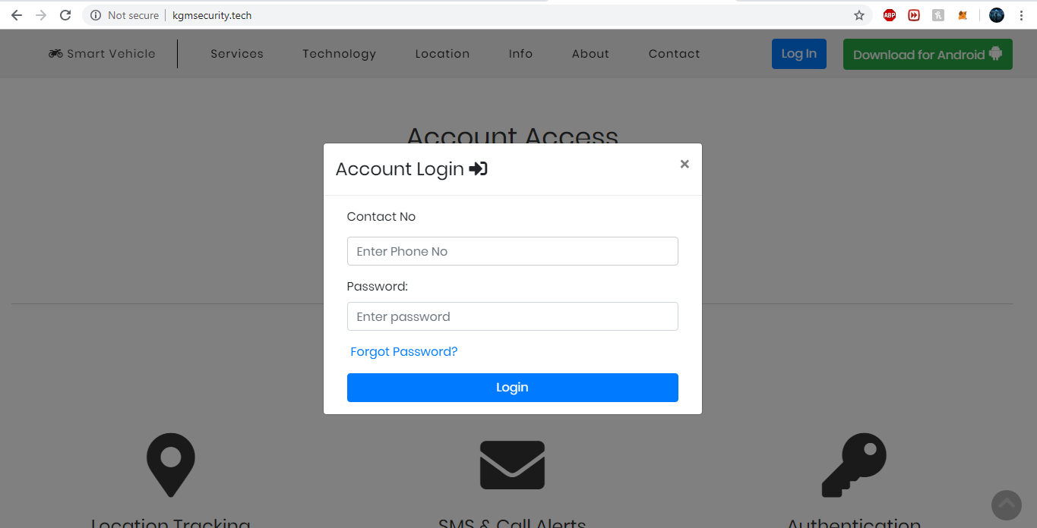

**Figure 19 : Login Page of Website Application**

**43**

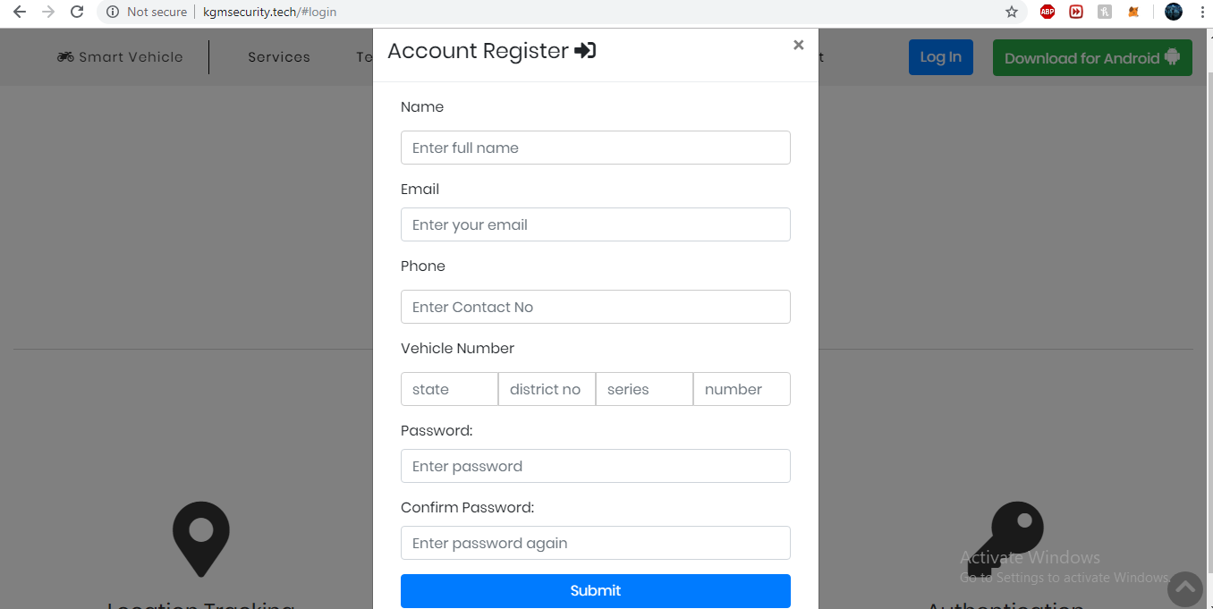

**Figure 20 : Sign up window for website**

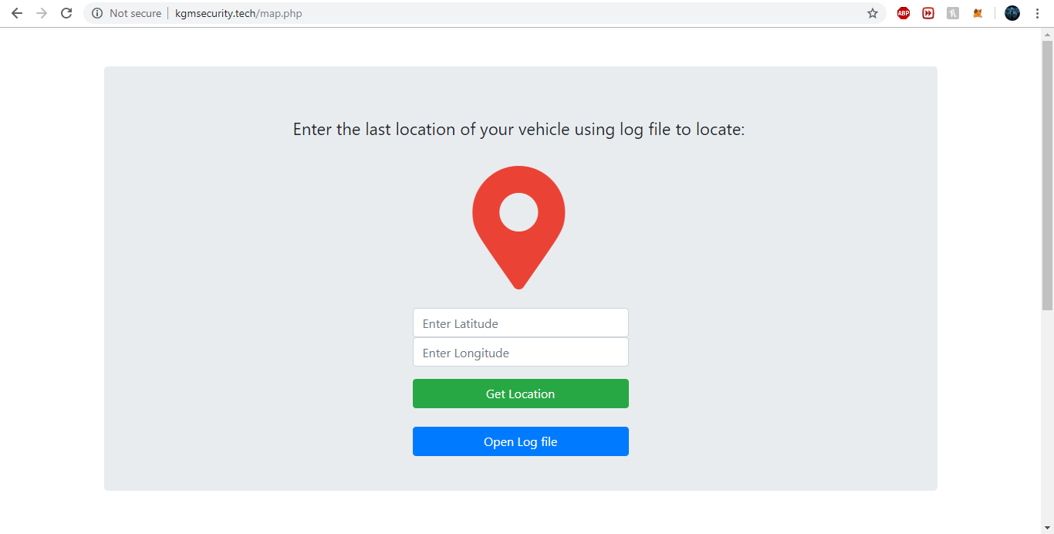

**Figure 21 : Location Tracking Page**

**44**

Android Application:

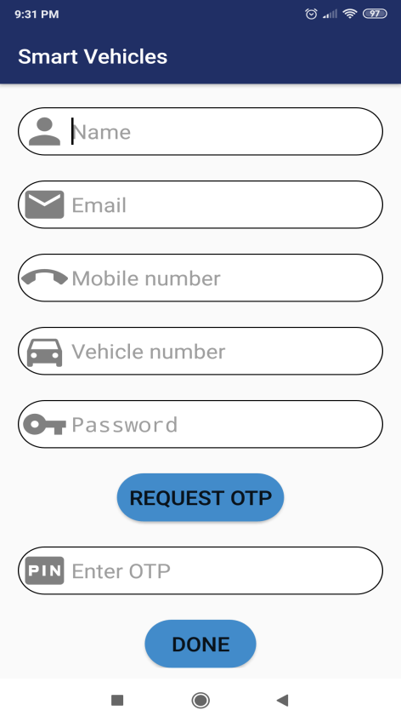 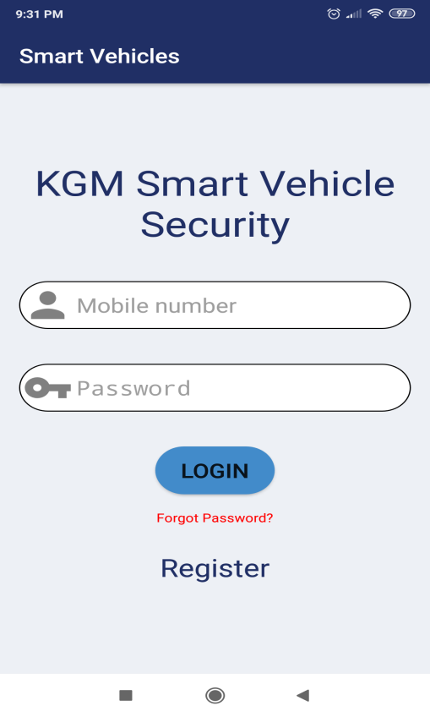

**Figure 22 : Registration and Login of User in Android App**

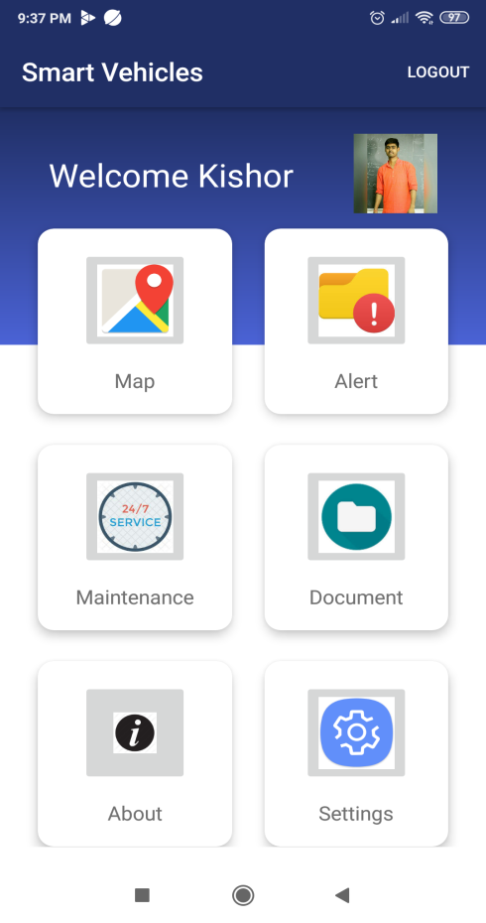

**Figure 23 : Dashboard Login of a User**

**45**

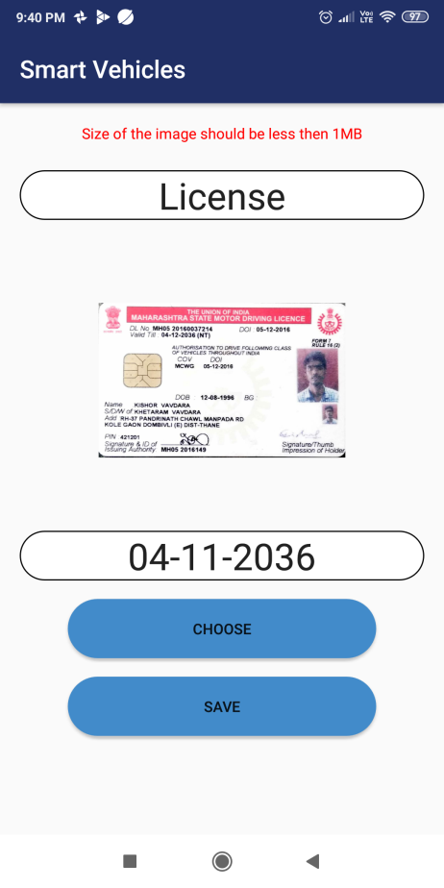 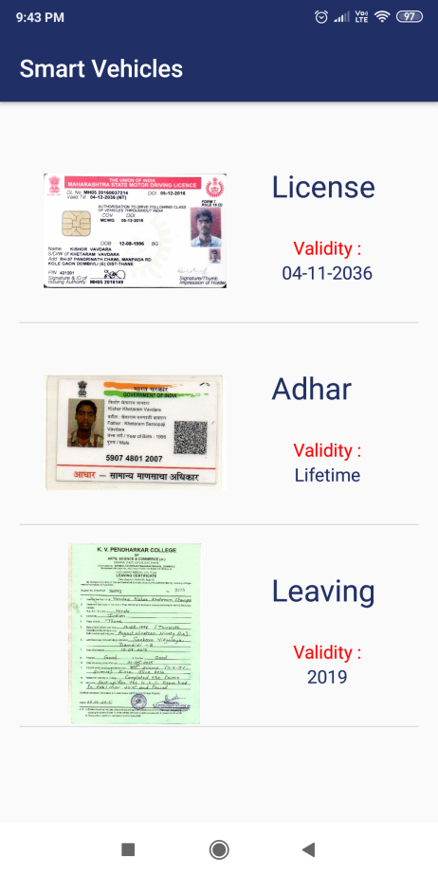

**Figure 24 : Document Manager for User**

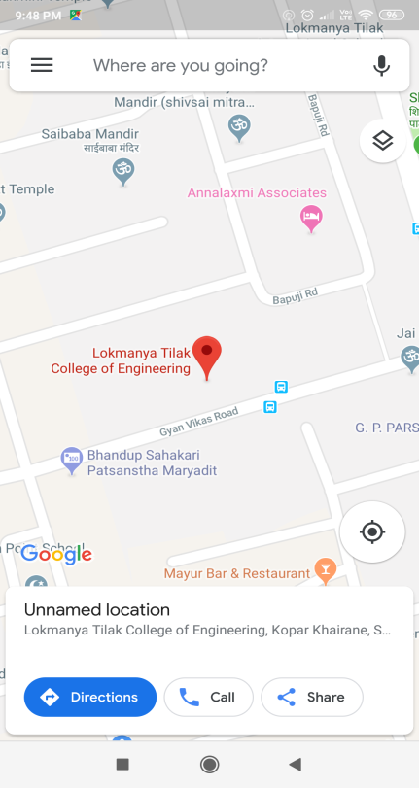 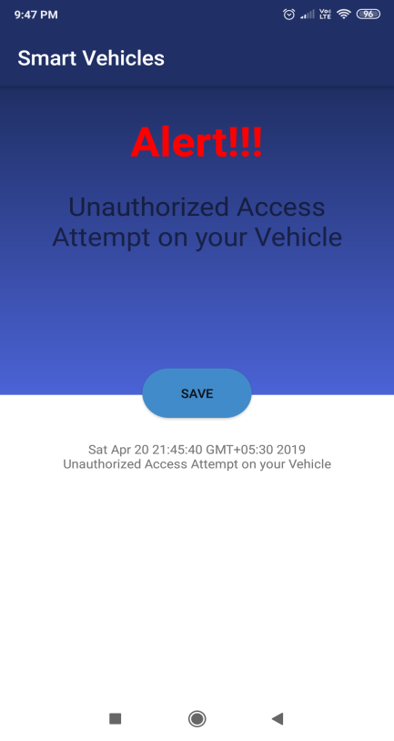

**Figure 25 : Location and Alert Notification via Android App**

**46**

**Chapter 6. Conclusion**

**6.1 Conclusion**

This report presents the work accomplished in the project “Smart Vehicle Security and Maintenance System using IoT”. The objective of this project is to solve the problem of vehicle security and efficient maintenance. In order to get introduced to this field, we conducted a literature survey, for identification of current problems faced by the society in general. Smart measure could be taken with the help of Internet of Things. In addition, we learned about the IoT hardware, functionality and Android application developememt which gave us the ability to set the objectives and limitations of our project. Given that the milestones of our project are mainly concerned with enhancing the vehicle security and protection of the vehicle from theft, we implemented and tested several techniques using IoT sensors, in order to identify which methods will contribute to our solution. These techniques include GPS/GSM tracking, RFID scanner, Fuel level tracking, Document management. The Hardware and Software requirements were finalized with the help of the the testing and designing phase. After finalizing the design step, we decide to use modular approach to implement the design. With the help of modular design additional modules could be integrated later with the arduino uno board. Various algorithms for getting input and sending output to the arduino board were decided and a time line chart was created for keeping a track of progress.

**6.2 Future Scope**

The second version of this project will boast of a fingerprint scanner for the authentication

of a user. If an intruder tries to break the fingerprint scanner an onboard buzzer will be alarmed. It

will also be have an upgraded GPS module which will ensure that the location can be tracked

more efficiently and effectively. The maintenance module will provide more features such as fuel

to empty,tyre pressure monitoring system and many more. In case of accidents or incidents the

app will call the nearest police station and emergency services. The system will also generate a six

month view planner so the user can review his/her vehicle health. The AI will also help user to

know how much fuel is been consumed and when the fuel is running low it will show the nearest

fuel stations. It will support voice command system to start/stop vehicle. The system will be

introduced to a Security Net. In this feature the user can add his/her friends to the Security Net

which will notify his/her friends if the vehicle is being stolen. User can customize his/her own

tune for the alerts via the app.

**47**

**Chapter 7. References**

1. Wikipedia, the free encyclopedia, Internet of Things applications Retrieved from: <https://en.wikipedia.org/wiki/Internet_of_things>
2. An Introduction to Programming the Internet of Things (IOT) Specialization Retrieved from: <https://www.coursera.org/specializations/iot>
3. “Pritpal Singh, Tanjot Sethi, Bibhuti Bhusan Biswal, and Sujit Kumar Pattanayak” - *A* *Smart Anti-theft System for Vehicle Security* Published in the International Research Journal ofEngineering and Technology (IRJET)
4. “Abhilash R. Lomate, Shilpa Mahore, Bhavesh S. Bhopale, Prof. Nilima R. Kharsan”-*Smart Anti-theft System for the Security of Vehicles – A review* Published in the InternationalJournal of Materials, Mechanics and Manufacturing.
5. Introduction to GPS/GSM IoT tracker

Retrieved from: https://www.instructables.com/id/Make-Your-Own-GPS-SMS-Security-Tracking-System/

**48**

**Annexure**

**Plagiarism Report**

**49**